**Business Analysis Foundation – Fundamentals**

Role of BA – Break down ideas, needs and requirements into smaller pieces that can come together to create a big picture. Business Analysts do this by identifying organizational needs, then gathering, managing and verifying information, to create solutions for business problems. Being a great Business Analyst is about helping your organization make better and more informed decisions.

Tools and Techniques used during different phases of project

Initiation Stage - manage the business objectives, ensure the objectives are valid and appropriate for the organization in the short and long term, ensure the core idea of the project remains in the forefront, and delivery of that idea is the ongoing intent for the project.

Planning Phase - all appropriate individuals are consulted, and their ideas heard, consider all stakeholders, project direction is always in the best interest of the business.

Project Execution Phase - ensure that changes to the project's products are considered and managed appropriately, need to validate any proposed changes to ensure they appropriately capture the change needed within the project, need to detect when a change may be needed and promote changes to the project that may be needed for the business. And lastly, in the event of a project change being approved, you should assist with changing plans to ensure the project moves forward appropriately. should play a significant role in product testing.

Closing Phase – Validate completion criteria

Role of BA

* Validate Objectives – Projects are used to create change, changes can significantly improve the abilities and efficiencies, seek to understand the process strengths and the weaknesses your organization uses, and then validate any improvements to be implemented by a project.
* Manage requirement process – Work with your organization team and gain a deep understanding of what the organization is doing today, and what will make the organization more efficient. You then capture that information using several of the following tools.
  + Flowcharts - provide step by step, as-is, and to-be processes. This captures what the current state of the organization is, and what the new desired state and expected outcomes will be.
  + User Stories - provide a picture of what people in the organization want to achieve.
  + Context diagrams - describe relationships between business areas, clients, and how they all fit together.
* Manage Relevant changes – Validate changes, promote changes, manage schedule impacts. When changes are introduced to a project, you need to adjust the schedule for the project and potentially the playing costs, as well as other items. With a breadth of knowledge across the project, the business analyst is well placed to help with these changes.
* Managing Testing
* Ensure completion criteria – Detailed criteria, look at the overall accomplishments made by the project and the capabilities of the processes and tools produced, and determine if those objectives were accomplished as intended

Characteristics and Skills

* Questioning and Listening
* Observing
* Hearing what is said and not said
* Interviewing
* Patience
* Communication skills and diplomacy
* Sustained enthusiasm
* Being logical

Mindset

* Belief that inefficiencies exist
* Spend significant time in understanding the existing as-is processes in order to facilitate effective change in your organization
* seek and enjoy knowing the detail, as well as the big picture.
* truly effective business analysts seek to understand and optimize how processes interact with each other. In short, a big-picture view to what is happening and could happen in the business is just as important as capturing and tracking the procedural details
* serve as the bridge between business and technical personnel. serves as a facilitator and translator from those stakeholders requesting the change to those who will deliver the change.

Initiation Phase

* Create Scope statement with stakeholders – High level agenda
  + What will be accomplished
  + Business areas that **will** be involved and areas which **will not** be involved
* Identify key stakeholders – Usually senior managers since they take decision, SME, people familiar with the processes, influential teams with specialized knowledge
* Create Business requirements based on inputs takes from stakeholders and scope statement. Business requirement is **a detailed list of what will be done to fulfil the project’s scope**
* Achieving Objectives – Determining requirements and outcomes, documenting requirements, reviewing and confirming requirements
* Identify completion criteria - A project needs to have a beginning and an end clearly defined to ensure expectations are well and truly aligned. Completion criteria should be stated in business performance related terms, such as productivity levels, cost savings or profit increases, compliance with regulations, and efficiency or percentage improvements from existing levels.

Ways to define Business problems and Opportunities

* use multiple techniques for information collection.
  + Individual and group interviews
  + Job observation
  + Documentation review
  + Systems review
  + Visiting multiple locations
* determine the perceptions of your project's sponsor - Take the information you have collected using the techniques I have described here and contrast them with the perspectives of your sponsor. It can be a great way to adjust and focus your findings.
* Look for most common areas for improvement
  + Look for manual steps in a process
  + Swivel Technology - This is when a computer user looks up information in one computer system, swivels in their chair, and enters the same information in a different computer system.
  + check for conflicts or inconsistencies in process execution.
  + look for processes without a purpose.

Business Objective – How to establish objectives

* Use common structures- Financial elements like profit increases, cost decreases, or productivity measures; surpassing your competitors in price point or capability; achieving compliance with regulations
* Establish a target for objectives – be specific, understand and share the starting point
* Let everyone know how target will be measured – parts/person or parts/hour
* Gaining agreement – schedule and allow for training, change marketing material with customers to promote new products or capabilities, and put new performance monitoring in place, and manage employees to ensure new processes are executed and new targets are measured.
* Examine downstream processes – ensure that business can handle the results of your business objectives should they be achieved
* To verify the project will deliver the expected outcomes and contribute to the overall goals of the organization ensure the new project objectives match up to what the organization is trying to achieve. You do this by aligning your project objectives to one or many of the overall organization's strategic objectives.

Capture Business Information – As a BA, a large part of role is centred on fact finding and gathering information. Most effective way to gather info is to look for already available information:

* Company website
* Intranet sites
* Annual reports
* Strategic Objectives
* Business plans
* Annual Operations plans
* Process and tools
* Industry magazines
* Blogs
* Research Magazine

Using diagram to help confirm perception. 5 diagrams

* Organizational Chart – used to identify functional areas and relevant stakeholder
* Stakeholder map – Picks relation of a stakeholder to the solution and to one another. Who is responsible for what and how different artefacts gets reviewed, approved and ready for implementation.
* Context Diagram – used for confirming scope and address all necessary integration requirement in the analysis
* Business Use case diagram – help to get the big picture of who is using what and what they can execute.
* Business Process / Activity diagrams – provides process in detail. Complements the use case diagram as it provides a picture describing the basic, alternate and exception process

BA contribution to success in following 5 areas:

* Project and scope definition – tries to learn about issues and opportunities for improvement in context of larger framework, map the change areas and identify when the business problem emerged.
* Planning the analysis – The perspective given by BA helps identify additional business needs, where to collect that info and define analysis work
* Procedure analysis – Using a top down approach, allows us to gain perspective and direct the work of digging deeper in departments, processes and procedures.
* Stakeholder interviews – Recognize the general culture, values and interaction of people
* Solution design – Allows to understand strategic plan and business objective

Stakeholders Groups

* Clients and customers - the recipients of the outcome, product, or service of the project.
* Governance Area - he systems and processes that are in place for ensuring proper accountability and openness in the conduct of the business. These are the legislation, regulation, policies, procedures, business rules and guidelines that the project must comply with.
* Service Provider – suppliers
* Partner stakeholders – preferred contractors

Understanding stakeholders - A stakeholder can be a person, department, or functional area, internal or external to the organization. And it's directly involved with or affected by the area being analyzed. Identifying stakeholders and documenting relevant information regarding their interests, involvement, dependencies, influence, and potential impact on the success of the project early on, enables you to plan and react to their evolving needs.

Ask “who is missing” after identifying stakeholders and while having meeting with stakeholders. Enter details in stakeholder context diagram and share with project owner.

Stakeholder analysis table

* What do they value most?
* How will their commitment to the project and the work be measured?
* What authority do they have to effect the required change?
* Have they clearly communicated their needs and requirements?
* What areas/stakeholders are in conflict?
* Are they willing to take ownership upon project completion?
* Who will have the most influence/impact on project success?
* How do you handle the stakeholder that gets the short end of the stick?

Designing the requirement

Four main stages to collect the requirement

* Collect Requirements – Understand the scope, spend time with manager and sponsor to understand the expectation is, watch out for out-of-scope items (scope creep)
* Gathering Requirements – Interview, brainstorming sessions, observing a job or process, surveying, joint requirement sessions
* Requirement refinement – Determine fir in overall project context, ensure fit with business strategies and still align with project objectives, classify requirements – mandatory, important, nice to have
* Refinement Results – ensure that requirements are understood by many, complexities identified and clarified, requirements prioritized, which requirements are necessary and understanding of overall fit
* Requirement Verification – Decide who should confirm, avoid analysis paralysis, use peer review or formal inspection, verify against process models. Verification process also generates successful acceptance criteria – it should be measurable, specific and unambiguous and tied back to the requirement. Requirements are then signed off by project sponsor and customer

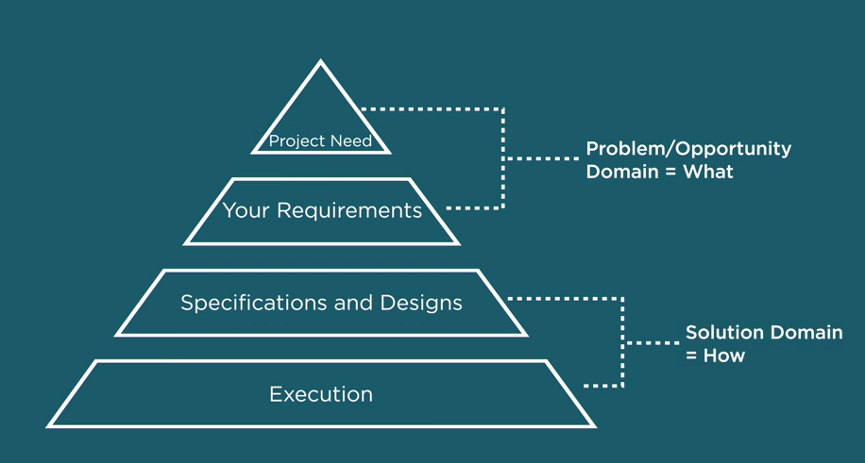

Differentiate between requirements – what or how

Requirement breakdown Structure

Stakeholder requirements –

SMART

* Specific – requirement wording is clear, concise and unambiguous
* Measurable – has criteria which can be tested
* Achievable – can be successfully attained within project environment
* Realistic - Appropriate too project scope and available resources
* Traceable – can be associated with stakeholder, process or system

Split solution requirement

* Functional Requirement – Actions and activities are needed to deliver against the stakeholder requirement. Look for explicit and required implied actions to deliver against the requirement.
* Non-functional Requirement – Certain conditions or capabilities that need to be in place to enable actions or activities to happen. They enable functional requirements to happen, they define parameters, attributes, constraints and other characteristics
* Transition Requirements – What is needed to confirm acceptance of the stakeholder requirements and deliver against the high-level business. Documenting acceptance criteria.

Explicit vs Implied Requirement

Brainstorming Session – Use when customer doesn’t know what he wants

Prefer quantity over quality – more ideas, more valuable. Make it time boxed, set the starting point and objective. After gathering all requirements, sort it through the process:

* Flag
* Categorize
  + Mandatory
  + Important
  + Nice to have
* Prioritize

Observing a job – Active and Passive. Follow KRAC approach to analyse the job observation and review each step of the process:

* **K**eep -
* **R**emove – what is obsolete and needs to be removed
* **A**dd – What is missing and needs to add
* **C**hange – What is not working and needs to change

Surveying – A method for collecting information from a selected group of people, using standardized questionnaires. Surveys require

* Selecting stakeholders
* Determining Method
* Analysing results

Producing Business rules and requirement traceability

Business Rule –

Requirement verification technique

* Peer-review approach
* Formal Inspection Technique – Disciplined approach including SMEs
* Acceptance Criteria
  + Criteria is valid when
    - Completion criteria tie back to high-level business requirements
    - Requirements are quantifiable and clear
    - Traceability matrix has been applied
    - Completion criteria signed off by sponsor and customers
* Process to manage verification findings such as change request and issue management

Procedure Manual and training material

Viable acceptance criteria have following characteristics

* They reflect specific business outcomes
* They reflect the desires and expectations of your stakeholders
* They set or reinforce project priorities
* They include specifics on how they will be measured

Acceptance criteria can change

During Testing

* Create acceptance test cases – Prepared from end user perspective. Good test case – Specific, easy to understand, measurable elements
* Execute the test cases against the created solution
* Work with the solution provider until stakeholders are happy

Role of BA during Testing

* Writing test cases
* Ensuring test cases are executed
* Answering questions
* Verifying results

Testing techniques